Tools for Networks_v1.0

Release note: version 1.0

Author: HyungKwang

Date : 2019.08

Table of Contents

1. Introduction

* Intro
* Building Environment

1. Contents.

1). ‘Repeated task’

1. How to save logs
2. How to run

1). ‘Repeated Task’

1. Revision History
2. Feature release.

1) ’Collecting system outputs when problem occurred’ expected on Q4 2019

2) ‘DHCP shooter.v1 (DHCP/Release)’ expected on Q1 2020

1. Introduction.

* Intro
* While working as a TAC, I’ve experienced those below continuously. So this is to help others who are using Juniper production with this Tools.

1. How to collect system outputs continuously without using shell script.
2. What to collect at a production, when problem occurred.
3. How to simulate DHCP packets when handling BRAS features.

* Building Environment.
* Based on Juniper MX product. Other vendor’s would not work properly.
* Building environment : Python 3.7.2, PYQT5 & Designer
* Released 2 types as

1. ‘**Tools for networkers.py and Window_ui.zip**‘: to run it, you have pre-installed python 3.7 and PYQT5
2. ‘**Tools for Networkers.zip** : without Python&PYQT5 installation, simply execute it.
3. Contents.
4. ‘Repeated task’

* Task performed via Telnet access
* To help someone who feels hard to create Shell script or other script to run a repeated commands or tasks.

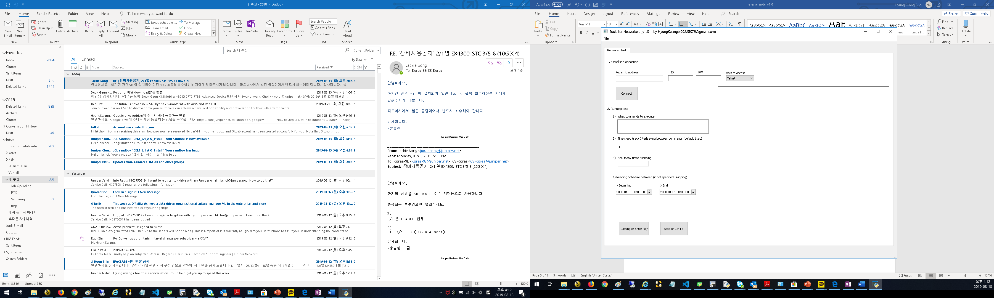

1. How to save logs
2. Go to ‘Files’ -> ‘Save logs’.

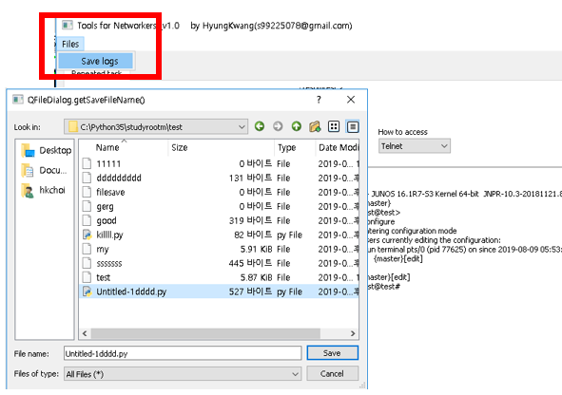

1. How to run

1). ‘Repeated Task’

1. First of all, copy/check you have 3 files in your python dir. \***\*you have to install python3.7.2 , PYQT5 and add python env path properly on your working dir.**

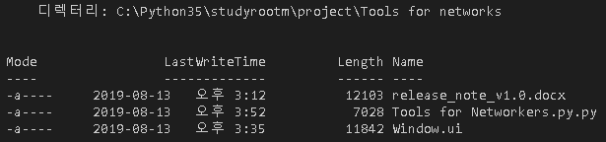

1. Run it

* To run it, you need 2 files “**Tools for Networkers and Window.ui**”.



Or

1. If you downloaded/extracted ‘**Tools for Networkers.zip**’ files, by simple double-clicking “Tools for networks.exe”, it can be run.

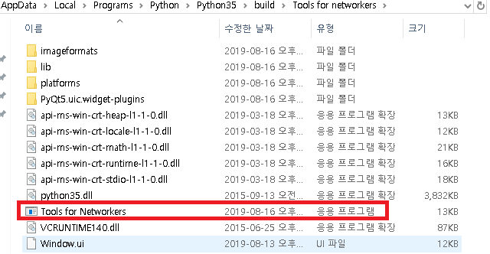

1. Once the Tool popped-up, Put ip & id & pw, and check connectivity.

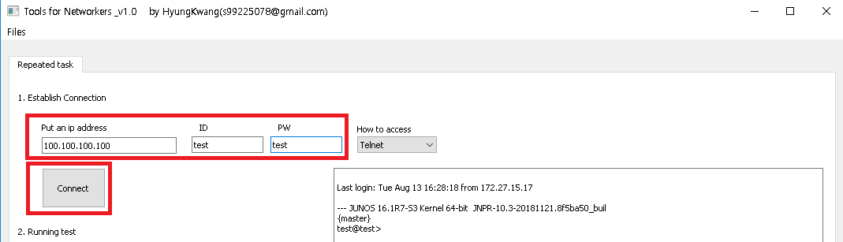

1. If connection successful, go to ‘2. Running a test’

* Take a look at “1).What commands to execute”

If you want to run several commands, you have to add “**;**” among commands

* Ex) set interface ge-0/0/0 mtu 9000**;** commit**;** delete interface ge-0/0/0 mtu 9000**;**run show interface terse | match ge-0/0/0
* if possible, try to append ‘no-more’ after commands. To avoid logs are stuck in buffer just like the same as Telnet session.

Ex) run show version | no-more, run show log messages | no-more

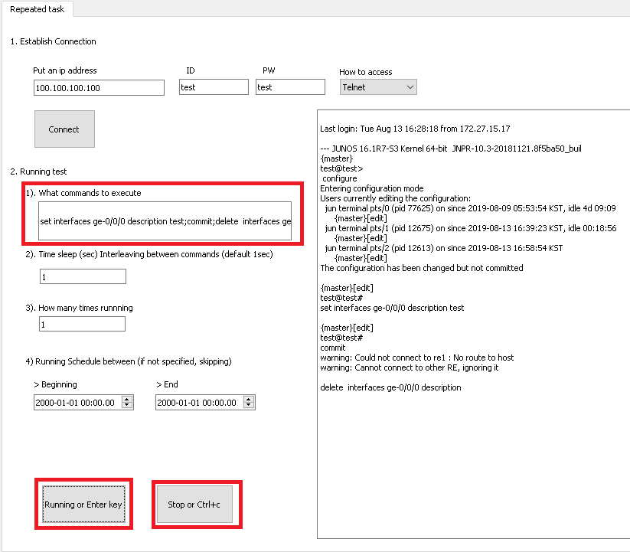

1. As this ‘Repeated Task’ works on Telnet session, you can do the same thing as what you do in Telnet.

(Accessing to System, and executing shell command or whatever)

Ex) start shell user root, /usr/sbin/cli -c "set cli timestamp, uname -a and so on

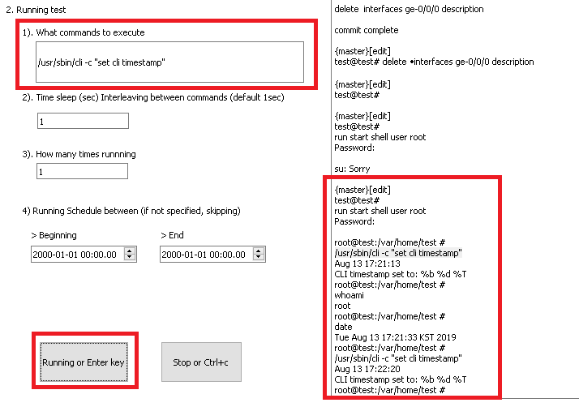

1. Revision History

* Not applicable yet.

1. Future Release

1) ’Collecting system outputs when problem occurred’ expected on Q4 2019

2) ‘DHCP shooter.v1 (DHCP/Release)’ expected on Q1 2020